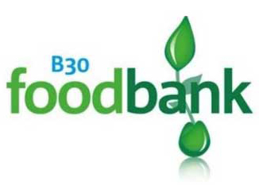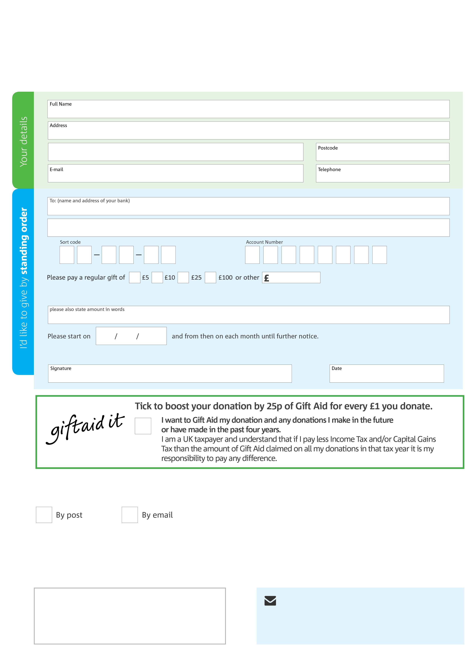­

**Data protection**

B30 Foodbank is committed to protecting your privacy and will process your personal data in accordance with the Data Protection Act 1998. B30 Foodbank collects information to keep in touch with you and supply you with information relating to our work. B30 Foodbank will never sell or pass your details to anyone who isn’t directly working on our behalf.

**We would love to keep in touch with you so we can update you on our work. You can change your preferences any time by contacting us on 07582143972 or emailing us at info@b30.foodbank.org.uk**

**Please tick here if you would be happy to receive communications from us:**

**B30 Foodbank’s bank details:**

Lloyds bank

Sort Code 77-85-14

Account Number 34292560

**Please send your completed form to**

B30 foodbank

The Cotteridge Church

24 Pershore Road south

BIRMINGHAM B30 3EJ

This cancels any previous standing order instructions to B30 Foodbank

To B30Foodbank each month,

B30.foodbank.org.uk

Reg. Charity No:1143091 | Reg. in England & Wales april 2016