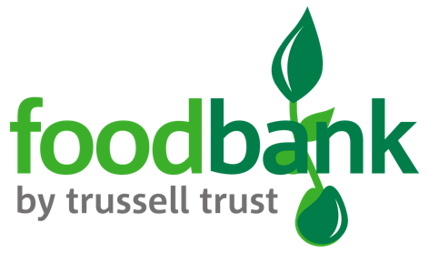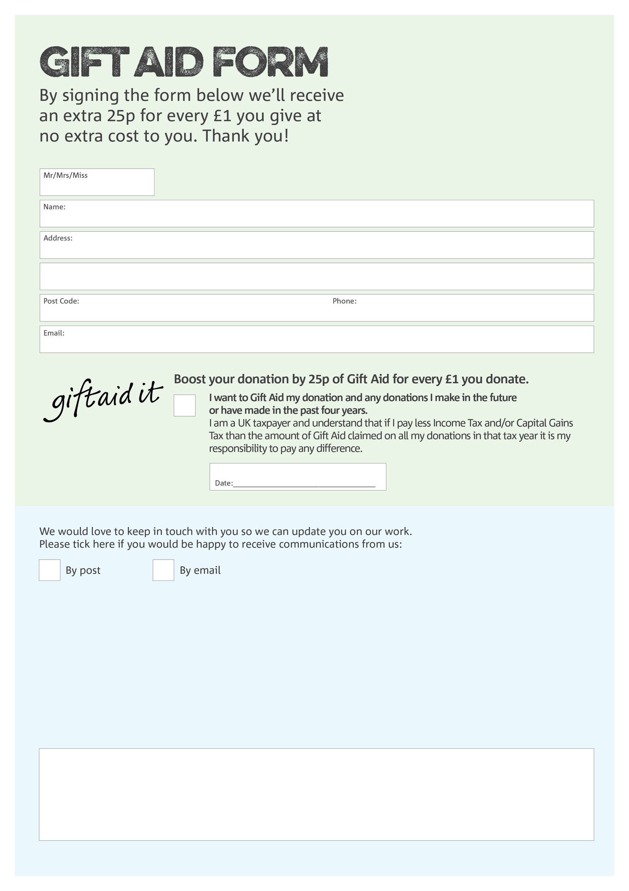

**Data protection**

B30Foodbank is committed to protecting your privacy and will process your personal data in accordance with the Data Protection Act 1998. B30Foodbank collects information to keep in touch with you and supply you with information relating to our work. B30Foodbank will never sell or pass your details to anyone who isn’t directly working on our behalf.

You can change your preferences any time by contacting us on 07582143972 or emailing us at

Info@b30.foodbank.org.uk

We would love to know why you have chosen to donate to b30foodbank. If you would like to share your motivation let us know below:

Charity Number 1143091 Registered in England and Wales